Name: Ryan Loe Suwandi ID: 55724681

1

$1101100 mod 11=0$

$$Codeword=1101100$$

$111110 mod 11=1$

$$It will receive 1101101 and recognize it is an error$$

$110110000 mod 1011=010$

$$Codeword=110110010$$

3. Yes it can since it g2(x) has more than one term

$g1\left(x\right)∙g2\left(x\right)= x^{4}+x^{3}+x^{2}+2x+1=11101$

$$1101100000 mod 11101=1111$$

$$Codeword=1101101111$$

2

1. 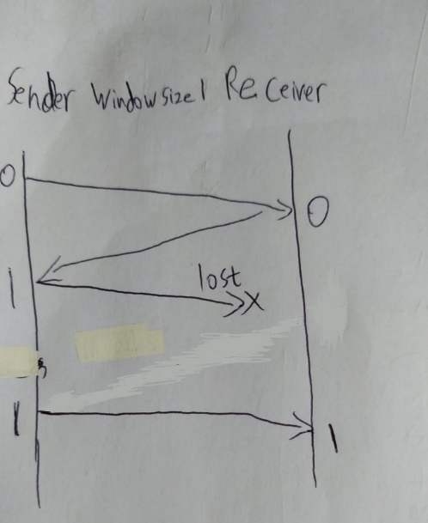
2. 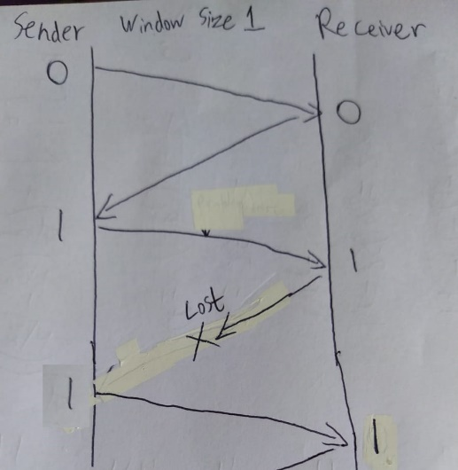

3

$$Pf={10}^{-4}$$

$$nf=256 ×8=2048$$

$$no=25 ×8=200$$

$$efficiency={\left(1-{10}^{-4}\right)}^{2048}\left(1-\frac{200}{2048}\right)= 0.735$$

4

|  |  |
| --- | --- |
| 3 | AI11 |
| 4 | AI21 |
| 5 | AREJ1 |
| 6 | AI11 |
| 7 | AI21 |
| 8 | AI31 |

1. 